**Control-Flow Graph Definition**

Related to traditional notion of flow charts

**Example program 1:**

while (i < 10) {

println(j);

i = i + 1;

j = j +2*i + 1;

}

Corresponding control-flow graph:

[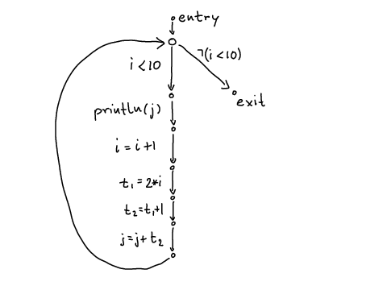](http://lara.epfl.ch/web2010/_detail/cc09:cfg.png?id=cc09%3Acontrol-flow_graph_definition&cache=cache)

**Example program 2:**

int i = n;

while (i > 1) {

println(i);

if (i % 2 == 0) {

i = i / 2;

} else {

i = 3*i + 1;

}

}

Corresponding control-flow graph:

[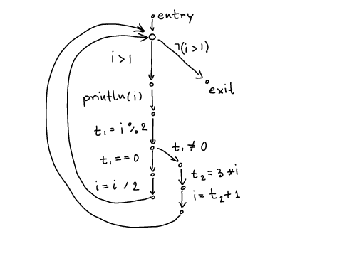](http://lara.epfl.ch/web2010/_detail/cc09:cfg2.png?id=cc09%3Acontrol-flow_graph_definition&cache=cache)

**Definition:** Control-Flow Graph (CFG) is graph $(V,E,L)$where

* $V$is set of CFG nodes, representing program points
* $E \subseteq V\times V$is a multiset of CFG edges (represent how **control flows** from one point to another)
* $L : E \to ST$gives a CFG statement for each edge
  + statements
  + conditions

[Side Note:](http://lara.epfl.ch/w/cc09:control-flow_graph_definition#folded_1)

In the example, what are V,E,L?

atomic expression = variable or a constant

ST statements are simple:

* quadruples: x = y * z (y,z are atomic expression)
* copy
* procedure calls (parameters are atomic)
* relational operators between atomic expressions

Notion of Basic Blocks: straight sequence of nodes (no jumps to or from the middle)